

COMPUTER SCIENCE DEPARTMENT

Total Marks:
Obtained Marks:

Computer Networks and Data Communications

Labtask 10-11

Submitted To: Sir Ammad Noor

Student Name: Ubaid Bin Waris

Reg Number: 2212416

COMPUTER SCIENCE DEPARTMENT

Task 1

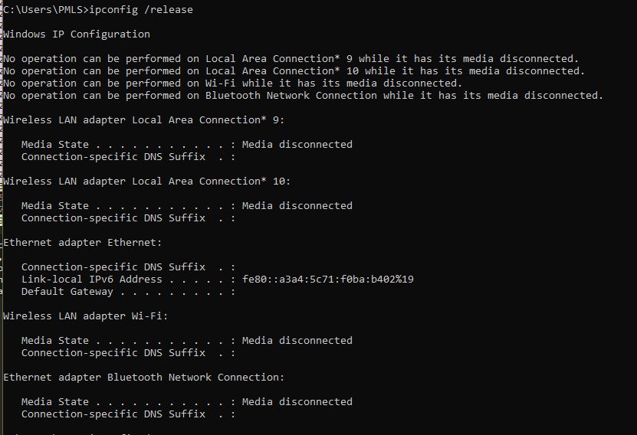

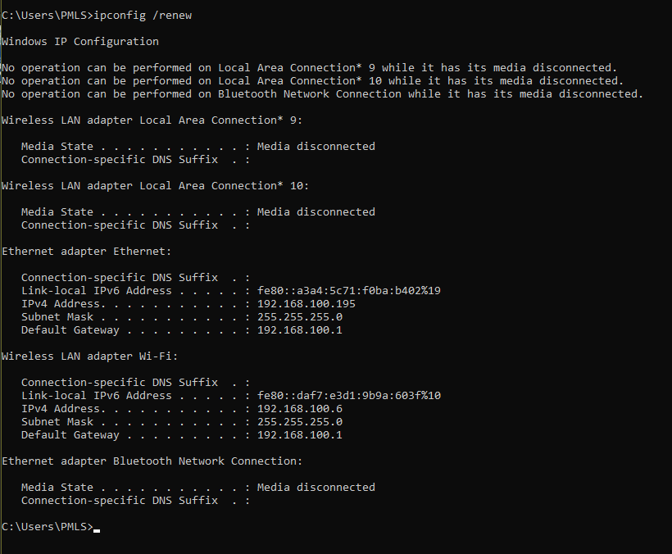

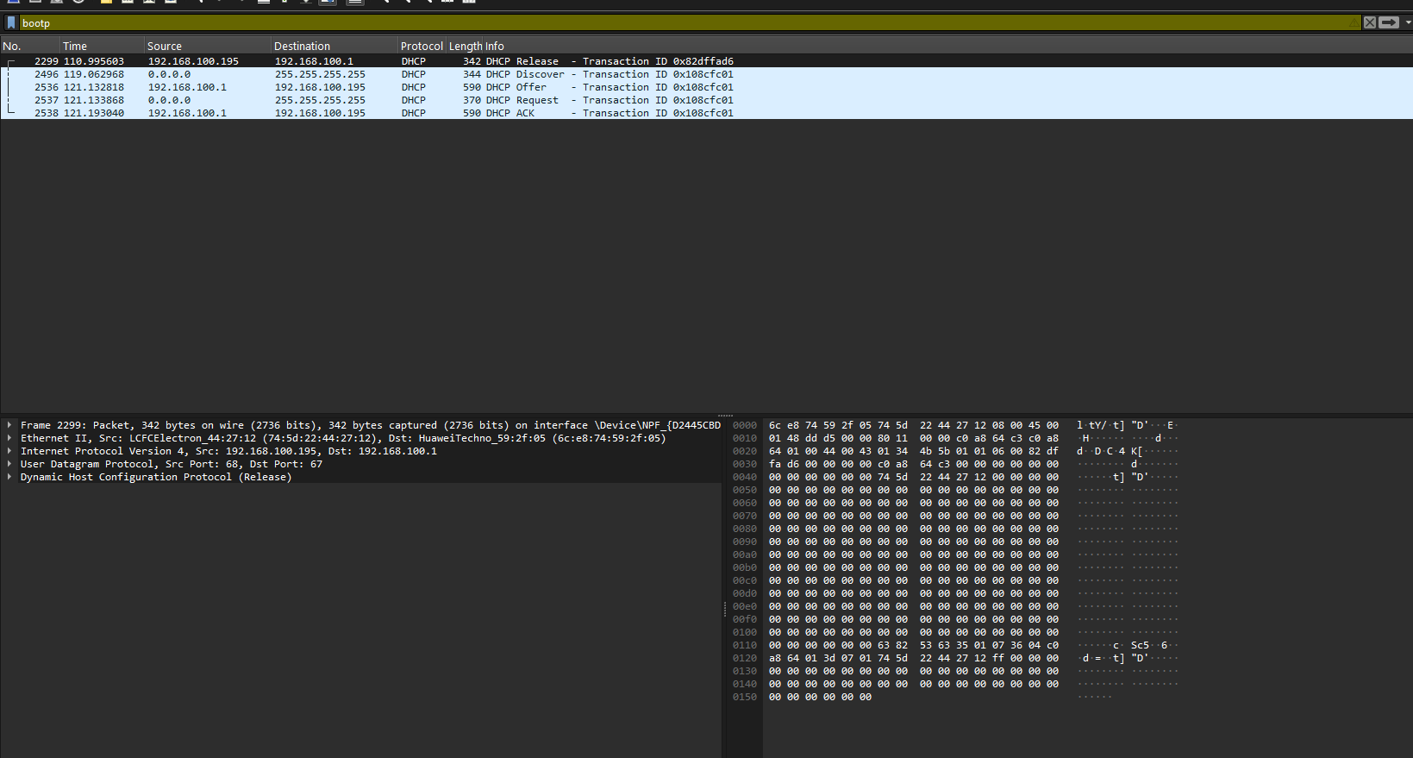

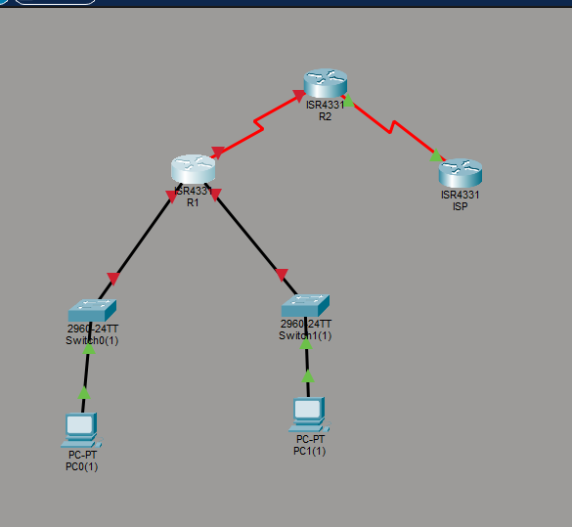

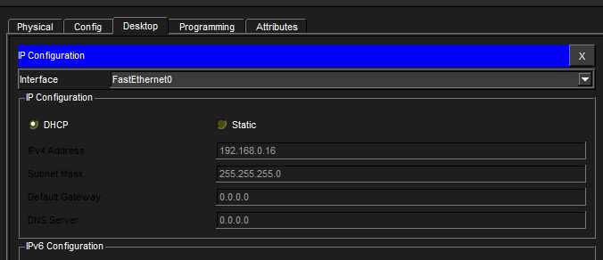

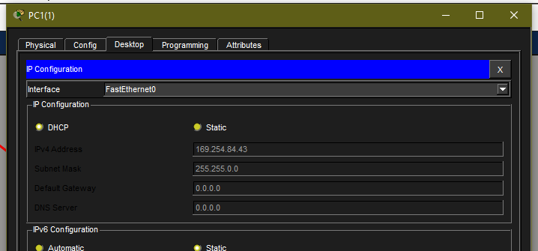

enable
configure terminal
hostname R1

! Configure the interface connected to the switch
interface GigabitEthernet0/0/0
ip address 10.0.0.1 255.0.0.0
no shutdown
exit

! Exclude router IP from DHCP pool
ip dhcp excluded-address 10.0.0.1

! Create DHCP pool
ip dhcp pool LAN_POOL
network 10.0.0.0 255.0.0.0
default-router 10.0.0.1
dns-server 8.8.8.8
domain-name mynetwork.com
exit

! Save configuration
end
write memory

